Curriculum Vitae
Name  Family status  Date of BirthPlace of Birth  Position | Luniov Sergiy  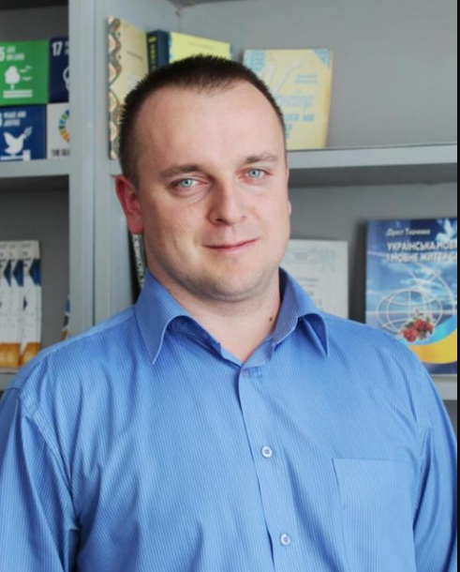  maried  22.08.1983  Lutsk - Ukraine  doctor of physical and mathematical sciences,  professor of the Department  of Physics and Higher Mathematics  Luniovser@ukr.net
DEGREES RECEIVED:
Degree | Institution | Department | Year
MSc | Lesya Ukrainka Volyn National University (Ukraine) | Physics and Higher Mathematics | 2006
doctor of physical and mathematical sciences |  |  | 2023
WORK EXPERIENCE:
Rank/Position | Dates | Department | Institution/Company name
Senior lecturer | 2009 to present | Physics and Higher Mathematics | Lutsk State Technical University (Ukraine)
NUMBER of WORKS published in scientific journals and conference proceedings:
https://orcid.org/0000-0003-0737-8703
total 130 publications including,

TOPICS OF NEW RESEARCH PROJECTS:
Deformation effects in semiconductors and semiconductor structures.
Mechanisms of scattering of current carriers in semiconductors.
Physics of low-dimensional structures and nanoelectronics.
Radiation effects and defects in solids.
Electrical properties of semiconductors and semiconductor nanostructures.
Band structure of semiconductors.
Physical and mechanical properties of epoxy polymers.

TEACHING COURSES:
«Physics», «technologies for designing sensors of physical quantities», «Fundamentals of nanoelectronics».

Personal skills and competences
Languages:
Ukrainian native language
English basic knowledges
Google Scholar: https://scholar.google.com.ua/citations?user=84_uXM8AAAAJ&hl=ru
Researchgate.net: https://www.researchgate.net/profile/S-Luniov
Academia.edu: https://independent.academia.edu/СЛуньов
ORCID: https://orcid.org/0000-0003-0737-8703

