Curriculum Vitae
Name  Family status  Date of Birth Place of Birth  Position | 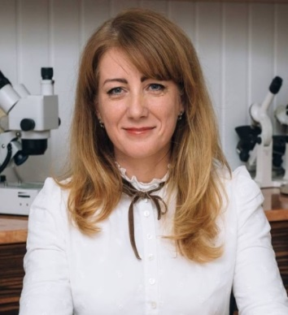  Svitlana YAheliuk  maried  01.12.1972  Lutsk - Ukraine  Professor of the Department of Commodity Research and Expertise in Customs Business  Lutsk National Technical University  s.yagelyuk@lntu.edu.ua
DEGREES RECEIVED:
Degree | Institution | Department | Year
Candidate of Technical Science (PhD) | Lviv State Agrarian University Kherson National Technical University (Ukraine) | - | 2003
Doctor of Technical Science (D.Sc) |  |  | 2019
WORK EXPERIENCE:
Rank/Position | Dates | Department | Institution/Company name
Professor | from 2020 to present | Department of Commodity Research and Expertise in Customs Business | Lutsk National Technical University
Associate Professor | 2004-2020 | Department of Commodity Research and Expertise in Customs Business | Lutsk National Technical University
Senior lecturer | 2004 | Department of Commodity Research and Expertise in Customs Business
Senior lecturer | 2004 | Department of Applied Mathematics
Assistent | 2003-2004 | Department of Applied Mathematics | Lutsk National Technical University
project activity
Responsible Performer | 2020-2023 | Recycling Technologies of Oleaginous Bast Crops Biomass Harvesting and Initial Processing | Scientific research work on State budgeting (Ukraine)
INTERNSHIPS:
2022 | Training courses for customs clearance specialists. Association of customs brokers of Ukraine
2021 | International Scientific and Educational Training "Writing and publication of academic research: special modern and global opportunities". Annamalai University, Department of Business Administration (India)
2018 | International Staff Mobility for Training program at the Polytechnic Institute of Bragança, ERASMUS (Portugal)
2017 | International Training Programme at the State Agrarian University of Moldova (Moldova)
NUMBER of WORKS published in scientific journals and conference proceedings:
https://orcid.org/0000-0002-7428-0848
SC 57207859769
total 140 publications including,
112 – monographs, publications in scientific journals, conference proceedings, 4 – tutorials.

TOPICS OF NEW RESEARCH PROJECTS:
The increase of quality and ecological security for bast crops harvesting and processing by means of machinery, devices and technologies development that utilize to the maximum plant primary potential.
The research of properties and quality assessment of modern eco friendly cellulose-containing materials.
Food Expertise
RESEARCH EXPERTISE:
- Deputy head of Expert Academic Council K 32.075.04 in the field 05.18.02 - the technology of cereals, legume-cereals products and mixed fodders, oilseeds and bast crops, 05.18.08 - Commodity research of nonfood goods
- Member of the editorial board of the scientific journal "Agricultural Machinery"
TEACHING COURSES:
Goods expertise, Food expertise, Technical regulation, International technical regulation, Quality management, certification and dealer’s occupation, Regulations database for expert mechanical engineering research
Personal skills and competences
Languages:
Ukrainian native language
English basic knowledges (B2)
Scopus: https://www.scopus.com/authid/detail.uri?authorId=57207859769
Google Scholar: https://scholar.google.com.ua/citations?user=w1jyVRsAAAAJ&hl=uk
Researchgate.net: https://www.researchgate.net/profile/Svitlana_Yaheliuk

