Curriculum Vitae
Name  Family status  Date of Birth Place of Birth  Position | 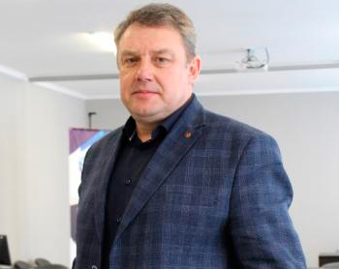  Igor Murovanyi  married  07.06.1969  Lutsk - Ukraine  PhD (Engin.), Dean of the Faculty of Transport and Mechanical Engineering  igor.murovanyi@lutsk-ntu.com.ua
DEGREES RECEIVED:
Degree | Institution | Department | Year
PhD | National Transport University  (Ukraine)  Lutsk Industrial Institute (Lutsk National Technical University)  (Ukraine) | Automobile transport  Automobiles and automotive industry | 2009
MSc |  |  | 1972
WORK EXPERIENCE: |  |  |  |  |  | Institution/Company name
Rank/Position | Dates | Department | Institution/Company name
Dean | from 2021 to present | Faculty of Transport and Mechanical Engineering | Lutsk National Technical University (Ukraine)
Academician | from 2019 to present | - | Transport Academy of Ukraine (Ukraine)
Head | 2013 - 2021 | Automobiles and Transport Technology Department | Lutsk National Technical University (Ukraine)
Associate Professor | from 2011 to present | Automobiles and Transport Technology Department | Lutsk National Technical University (Ukraine)
Senior Lecturer | 2009-2011 | Automobiles and Transport Technology Department | Lutsk State Technical University (Ukraine)
Assistant | 2004-2009
NUMBER of WORKS published in scientific journals and conference proceedings:
total 120 publications including,
92 - publications in scientific journals and in the Conference Scripts 4 – textbook, 2 – monography
ORCID: https://orcid.org/0000-0002-9749-980X
TOPICS OF NEW RESEARCH PROJECTS:

Development of the theory of controllability and stability of road trains and metrobuses. Development of the theory of the transport process of automobile transportation of passengers and cargo.

RESEARCH EXPERTISE:
- Improvement of traction and speed properties, productivity, fuel efficiency and environmental safety of cars, road trains and metrobuses.

TEACHING COURSES:
«Theory of transport processes and systems»
«Modern transport technologies»
«Modern technologies in road transport»

Personal skills and competences
Languages:
Ukrainian native language
English basic knowledges
Google Scholar:https://scholar.google.com/citations?hl=uk&authuser=1&user=Oueao_sAAAAJ
Researchgate.net: https://www.researchgate.net/profile/Igor-Murovanyi
Academia.edu: https://independent.academia.edu/ІгорМурований

